Manuscript Template

Title and Authors with affiliation and email:

Adsorption of Chromium(III), Nickel (II) and Copper (II) from Aqueous Solution by Activated Alumina
N.S.Rajurkar¹* , A.V. Gokarn² and K.Dimya²
1*. Chemistry Department, Pune University, Pune 411007, India
2. Environmental Science Department, Pune University, Pune 411007, India
Email: rnilima@rediffmail.com

Abstract:
Provide an abstract up to 300 words. It should briefly describe the objectives of the research, technique employed, and major results achieved and the conclusions. You should give special emphasis on novelty of your work.
Key words: Water analysis, ICPAES, Pune region

Introduction:

It basically deals with the introduction of the topic with review of the work in this field followed by scope of the work. The Introduction is NOT an extended version of the Abstract; never use the same sentences in both sections. The references¹ can be added at appropriate places in all sections as superscript on right side.

Experimental:
Describe the experimental procedure precisely so that they could be reproduced by another researcher. Do not describe in detail the methods commonly used or already published, cite them instead. Describe in short, the sampling procedure if used for your analysis.

Results and Discussion:
In this section, your results and their interpretation should be given and appropriate mechanism, in case if needed, can be highlighted.
For equations, use the equation editor or Math Type. Number the equations consecutively. The equations should be placed centered, while their serial numbers should be given on the same line in parentheses aligned to the right. Refer to them in the text as Eq. (1).
A= abc (1)
The result tables, figures, charts are to be included in as per the guidelines
Subsections under different headings
If needed they can be added with serial numbers in roman

Table 1: Table caption should be clear and concise
Parameter | Result/SI unit
Parameter 1 | 11.56 ± 0.03
Parameter 2 | 15.88 ± 0.05
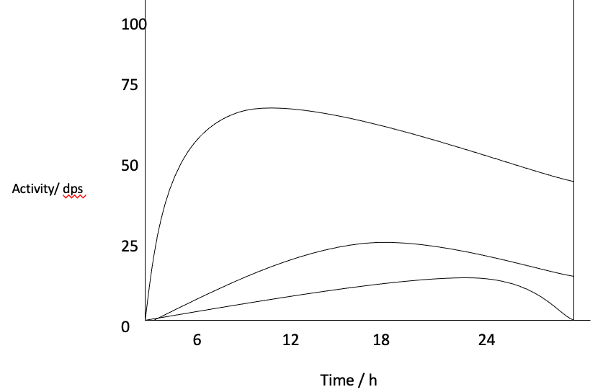
Fig.1: Write concise caption of figure
Photographs
Photographs should have a minimum resolution of 300 dpi. If any magnification is used in the photographs, indicate this by using scale bars within the figures themselves.
Conclusions
It should summarize the most important results, their novelty advantages, and limitations in 6-8 lines
Acknowledgement:
Acknowledgments of people, grants, funds, etc. should be placed here. The names of funding organizations should be written in full.
References:
Journal article:
Atomic Spectroscopy
Vol. 40(4), July / August 2019
*Corresponding author.
E-mail: arijita@barc.gov.in
:
ICP-AES Characterization of PHWR
Irradiated Thoria Bundles for Fission Products
A. Sengupta, B. Rajeswari, V. C. Adya and R. M. Kadam, Atom. Spect., 40(4), 127 2019.

Book name:
H. J. Arnikar, Essentials of Nuclear Chemistry, Wiley Eastern Limited, edn. 4 (1995).

Proceedings:
S. K. Saxena, N. S .Rajurkar,M. A. Majali, A. Shanta, A. Dash, M. Venkatesh, Proceedings of Nuclear and Radiochemistry Conference , Amritsar, India, PP. 555,(March 2005)

